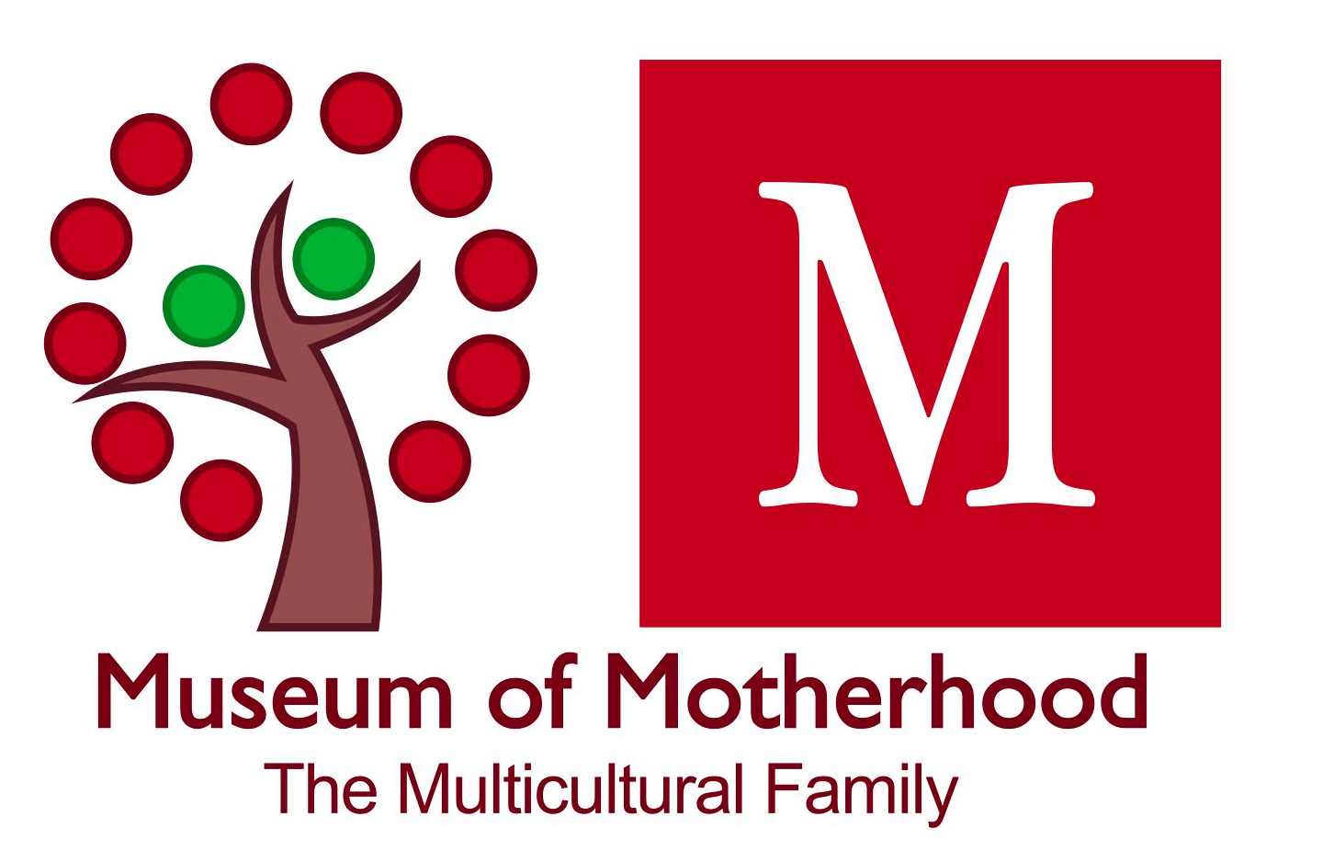
Museum Of Motherhood
538 28th St N.
St. Petersburg, FL 33713
Ph. 207.504.3001
877.711.MOMS (6667)
info@mommuseum.org
MOMmuseum.org

Dear Friend –
We are pleased to confirm your residency at the MOM Art Annex in St. Petersburg, Florida. The MOM Art Annex is the personal live/work space of Director Martha JOY Rose and registered as a non-profit 501c3 in the state of Florida.
The MOM Art Annex is vested with the mission of expanding the Museum of Motherhood footprint. MOM is located a few blocks from Central Avenue, 2.5 miles from downtown St. Pete, 6.5 miles from the beach.
Please read through this letter and take the necessary steps to prepare for your time with us. The next step is to review the calendar for available dates on our website. After you have done this, we ask that you communicate via email regarding the exact dates you hope to attend.
Residencies generally last for 10 days to two weeks. The Residency is free, but we ask those wanting to stay for longer than two weeks to contribute $125 per week to assist with utilities for any additional weeks. Extended stays must be requested in advance and are based on availability.
We ask that you identify something from your residency that will contribute in some way to MOM’s ongoing body of work. In other words, as part of the residency you will identify a tangible way in which your work intersects with MOM and benefits you as well as the museum.
- Specific examples include: organize one art or other project to be left onsite at MOM, conduct a community activity virtually or onsite during your stay and podcast it, photograph it, or conduct community research and share your responses. Other examples include painted furniture, zine, prints, poetry, mentions in your published credits, or other agreed upon donation of materials or resources.
- We also request that you do a minimum of two social media posts across FB, Insta, Twitter, Pinterest, or wherever you post, during your stay at MOM

In turn, MOM promotes its residents in the following ways: Accommodations & local support, internet and utilities, as well as an introductory blog posted on the MOMmuseum.org website featuring you, and your work, and an invitation to join our new online Community. Note that this is a self-guided residency, and you will be responsible for bringing your own supplies appropriate to your medium.
Once your residency contract has been signed, please join our new ONLINE COMMUNITY (Top tab MOMmuseum.org). Friend us on FB, Instagram, and Twitter. Please also send us a bio and photo at least two weeks prior to your residency along with your social media handles. These will be featured on the homepage of our website as well as archived on our residency page at the museum online. We will also be in contact to schedule an exit interview.
INDEMNITY CLAUSE: Resident shall indemnify, defend, and save MOM harmless from and against any and all claims, actions, damages, liability, and expense in connection with loss of life, personal injury, and/or damage to property arising from or out of any occurrence in, upon or at the Residency, or the occupancy or use by Resident of the Demised Premises, or any part thereof, or occasioned wholly or in part by any act or omission of Resident, its agents, contractors, employees, servants, Residents, or concessionaires. Notwithstanding the foregoing, Resident shall not indemnify and defend or save MOM harmless from any negligent acts occurring on the premises caused by MOM or MOM’s employees.

In the event MOM shall be made a party to any litigation commenced by or against Resident, the Resident shall protect and hold MOM harmless and pay all costs, expenses, and reasonable attorney's fees that may be incurred or paid by MOM in connection with such litigation and any appeals therefrom. Resident shall also pay all costs, expenses, and reasonable attorney's fees that may be incurred or paid by MOM in enforcing the covenants and agreements in this Lease Agreement.

Likewise, I agree that the Museum of Motherhood and MOM Art Annex may use photographs of me, my scholarship, or art images in advance of or during the residency, for any lawful purpose, including such purposes as unpaid publicity, advertising information about this residency, on our blog/web display, as well as social media associated with your time at MOM.
Please take note, that residencies are at the discretion of Owner/Founder Martha JOY Rose. This is a good will exchange, offered out of generosity and the hope of making MOM accessible to artists and scholars from different locations. Residents in turn, are expected to treat the property respectfully acknowledging there is expensive, irreplaceable art onsite. The property is a NO SMOKING, NO SHOES, NO PETS and in addition, no extra guests may be onsite without express written permission.
Finally, here is a summary of our Guest Residency process/ Please check all the boxes in the order these steps are presented:
- Identify calendar dates
- Confirm availability with our Residency Director
- Think about your project and what you hope to leave with MOM after your stay
- Sign this document and include your start and end date - as well as a description of the project you wish to leave with MOM
- Return signed document to our Residency Director
- Join our NEW *Online Community* at Mighty Networks (link available on our website MOMmuseum.org). Then CONNECT and join us on social media: FB (MuseumofMotherhood), Twitter (MOMmuseum), Insta (MuseumofMotherhood), Pinterest (MOMmuseum)
- Supply a photo of yourself and your work for a blog we will create two weeks before your arrival (Living Board President will create a blog post)
- Download our Guest Residency Booklet/ Residency Page online MOMmuseum.org
- Confirm you have completed these tasks TWO WEEKS before your Residency commences
- Check in with Museum Director, JOY (by phone) upon your arrival
- Make sure to perform a minimum of two social media posts during your stay
- Have an awesome experience!
- Exit interview with Guest Residency Director as well as a documented conversation identifying your contribution to MOM

There are several of us with whom you will have contact throughout your residency:

Connie B, Membership Director
Connie@MOMmuseum.org
Connie is your point person upon arrival. Setup and exit protocols go through Connie in the event of Joy not being onsite.

M. Joy Rose, Founding Director and Site Manager
Cell: 207-504-3001
Joy is your point person for any site-specific questions, information specific to the local artist community, and history and curation of the Museum. Call or text anytime!

Warmly,
[ Name ] on behalf of MOM

RESIDENT:
Arrival Date Exit Date
___________ __________
Printed Name:
___________________________
Signature:
___________________________
Date:
___________________________

MUSEUM OF MOTHERHOOD:
Signature:
Printed Name:

Date:

