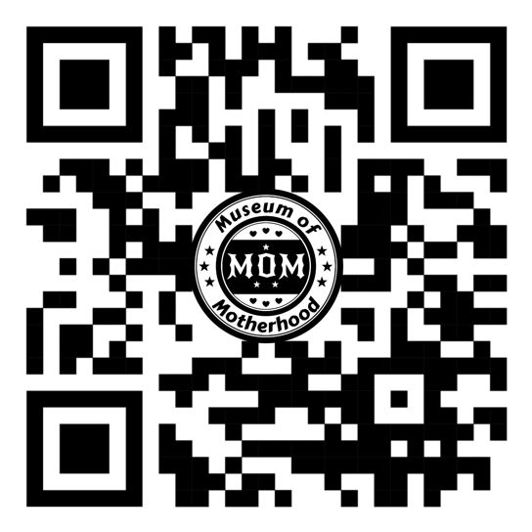
Museum of Motherhood February 2026 Press Release
FOR IMMEDIATE RELEASE: February 12, 2026
Museum of Motherhood Activates Community Through Arts, Advocacy, and Education This Spring
This spring, MoM will be visible in partnership with a Spotlight on Diverse Voices: ​Reel Equals International Film Festival Shines in Sarasota: ThroughWomensEyes.org and the internationally recognized educational & arts conference with two decades of impact.
The Museum of Motherhood (MoM) continues to deepen its role as a vibrant, community-centered educational and cultural institution, offering a robust calendar of exhibitions, public programs, conferences, and community appearances that explore motherhood as a social, cultural, and artistic force.
This spring, MoM will be visible in partnership with a Spotlight on Diverse Voices: ​Reel Equals International Film Festival Shines in Sarasota: ThroughWomensEyes.org
March 5 - 10 (in person and streaming)
Buy tickets here: https://twe2026.eventive.org/welcome
Opening Night Celebration, Friday, March 6 th

College of Art + Design auditorium.
Reel Equals 2026 festival themes include:
An entertaining opening night film that uses comedy to address a universal topic, human
anxiety, opening a door to a mental health issue everyone knows about.

The need for diverse stories; female filmmakers from 12 countries reveal topics ranging from stand-up comedy to elephants in India, motherhood to the war in Ukraine. We examine how media portrayals shape beliefs and opportunities; films reflect and reveal how influential media is on creating the ways we talk, think, and act and underscore the need for diverse voices in visual media. Changemakers; narratives that challenge stereotypes and elevate inspiring lives are central to the festival.

About REEL EQUALS International Film Festival in Sarasota with online streaming for audiences in surrounding areas and beyond. Buy Tickets: https://twe2026.eventive.org/schedule/6924a1a22d8b60b2af41489a
In St. Petersburg is MoM’s Escape the Womb experience—an interactive, educational installation that transforms learning about birth, reproduction, and maternal health into a playful, immersive environment. Designed to spark curiosity, conversation, and critical thinking, the Escape the Womb invites participants to solve challenges while engaging with real-world topics related to reproductive education, bodily autonomy, and caregiving. The experience reflects MoM’s commitment to making complex subjects approachable, inclusive, and memorable through hands-on learning.
In March, MoM will host its Annual International Academic Conference at the University of South Florida St. Petersburg campus—an educational milestone grounded in more than 20 years of international scholarship and public discourse. Since its inception, the conference has convened artists, scholars, caregivers (continued)
birth workers, healthcare professionals, and policy thinkers from around the world to examine motherhood through interdisciplinary, research-based perspectives.
“We are incredibly grateful to have a home for this conference at USF St. Pete,” said Joy Rose, MoM founder. “For more than two decades, this gathering has functioned as an educational forum for critical inquiry into caregiving, equity, labor, health, and cultural expression. Hosting it here allows us to share that knowledge directly with our local community while remaining globally engaged.”
The 2026 MoM Conference will feature panels and presentations focused on reproductive identities, maternal experiences, and the intersections of motherhood with art, policy, healthcare, education, and social justice. Offered both in person and online, the conference is designed to be academically rigorous while remaining accessible to students, professionals, and community members alike.
Beyond the conference, the Museum of Motherhood hosts educational events year-round, creating ongoing opportunities for residents and visitors to engage with contemporary issues through learning, dialogue, and community collaboration. A full calendar of events is available online: https://mommuseum.org/events-2.
About the Museum of Motherhood
The Museum of Motherhood (MoM) is Tampa Bay’s first and only women’s museum—an educational initiative highlighting m/others and others in the arts, sciences, and social history. Through exhibitions, public scholarship, and educational programming, MoM examines reproductive identity, birth, and parenting while exploring the social, psychological, and cultural forces that shape these experiences. By amplifying women’s voices and advancing public education, MoM fosters a compassionate, inclusive community that recognizes caregiving as a vital societal contribution.
Learn more at MOMmuseum.org.
Contact: Barbara Lynch | Museum of Motherhood | ambassadorbarb@gmail.com
Follow @MuseumofMotherhood and @AmbassadorBarb on Instagram and Facebook.

